Garment Production Monitoring System

**USER GUIDE**

Designed by: Madhushika Samankula

Index No: 1400134

Contents

1. Introduction 02
2. Logging into the system 02
3. GPMS Home Page 03

# Introduction

This user guide is designed to provide documentation for people who will use garment production monitoring system in Sumithra Garments on a day-to-day basis. This document is designed to be read by any user of this system, as most users will have access to the features documented here. Administrator functionalities are covered in a separate section of this guide.

Without any further ado, let’s begin!

# Login Form

Following Figure shows user login page which allows users to log into the system. All levels of users can log into the system in one page. When user try to log into the system check whether this user is valid user or not otherwise system display error message.

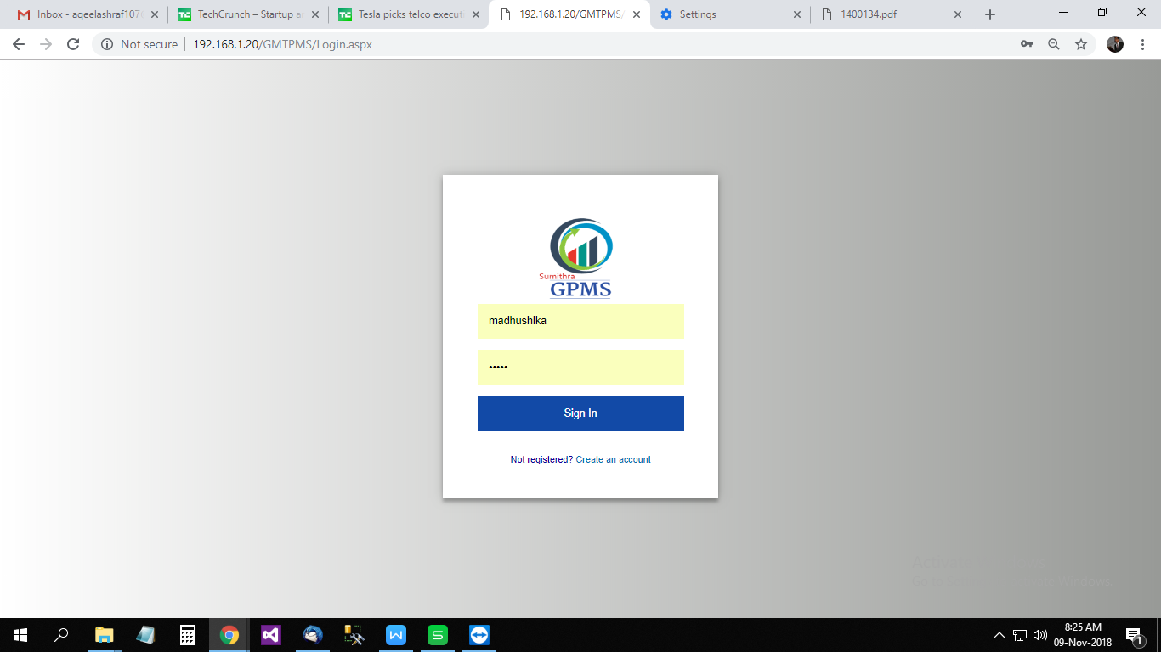

If a user account is not created initially, the user must request a login by clicking on the “Create an account” link which will direct the user to a page as shown below.

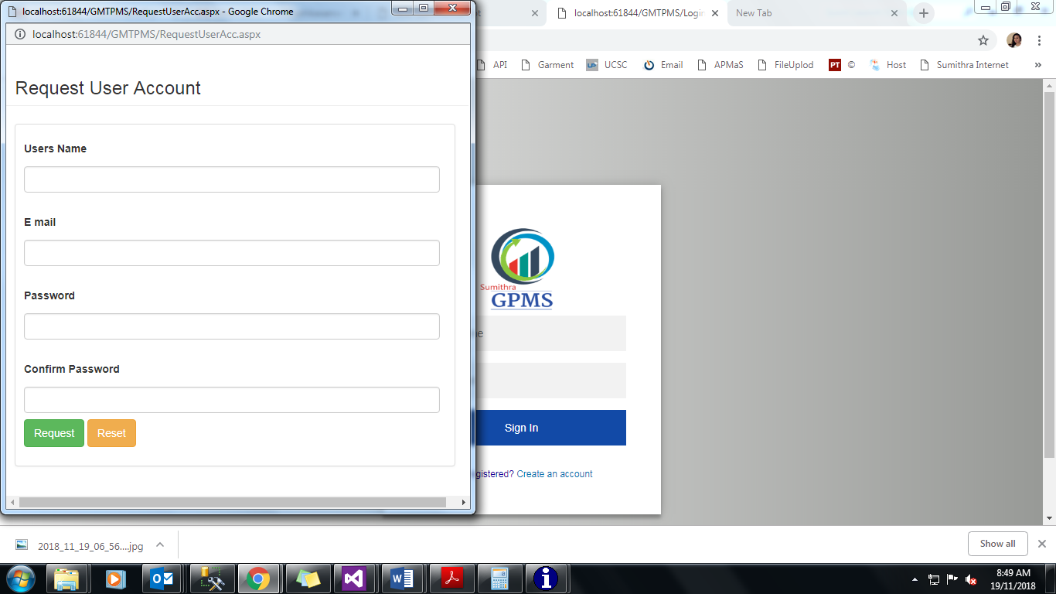

Here the user must ensure to enter a valid username and the email address. Also, the user must strictly adhere to the international password policy to set a strong password to the user account which will ensure the security of the system.

# Home page

After a successful login, the user will be directed to the home page of the system as shown in the screenshot below.

**Logout**

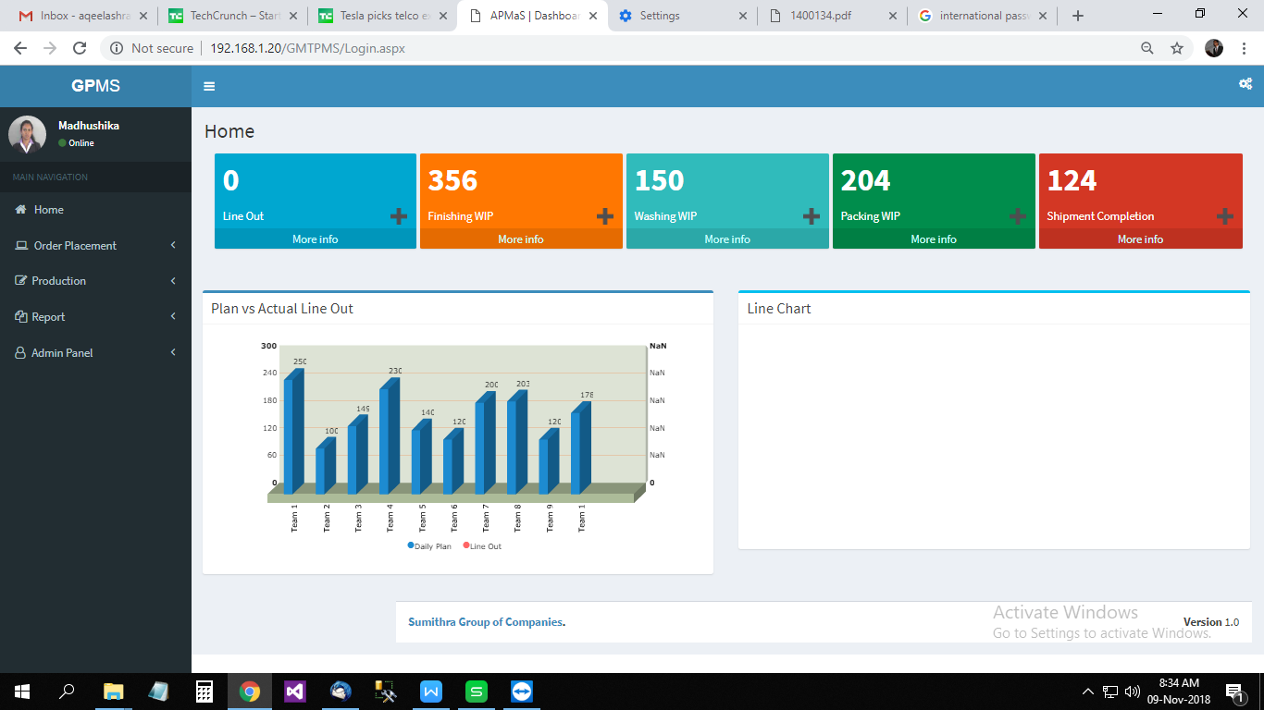

The home page on the left comprises of a sidebar which will enable the user to easily navigate all the important categories of the system. Clicking on one of the categories will list down all its sub components as shown in the screenshot below. The categories and its sub components will be discussed in detail in the later part of the document.

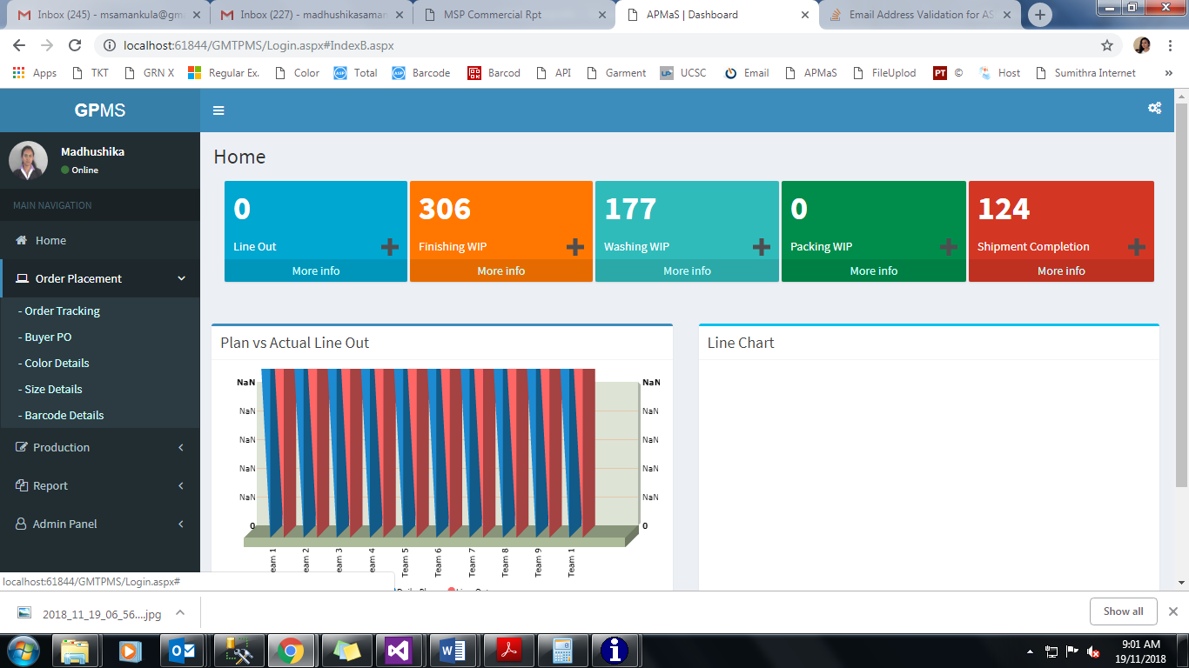

The home page also contains several widgets that were designed as per the clients requirements which will show a summary both in numeric and in graphical charts as shown below.

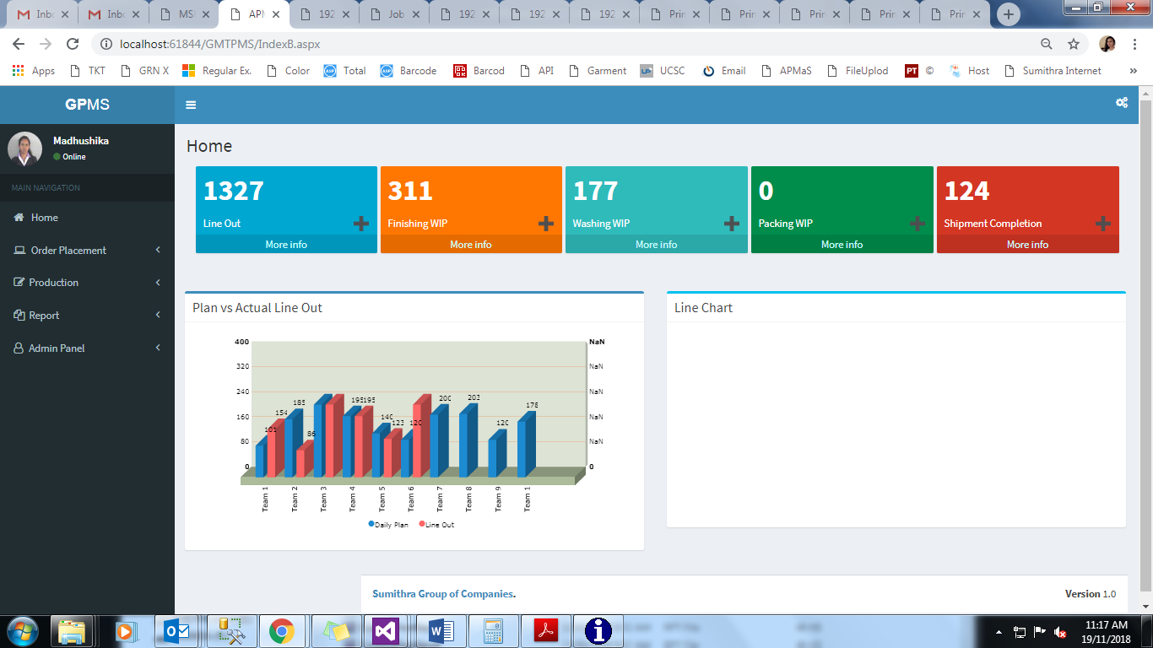

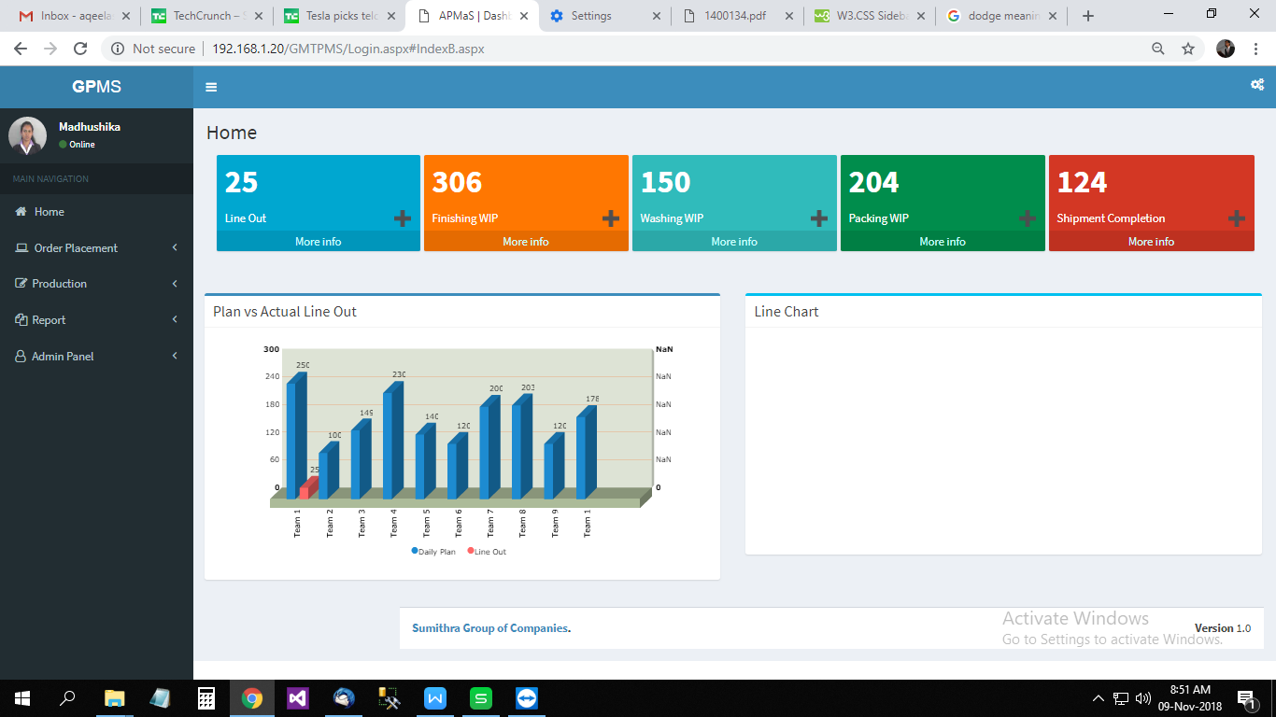

# Order Placement Module

Once the user click on the Order Tracking link, it will redirect to below given page. And users can add, update and delete details about the new orders using this page. The shown table of the below screen image will allow the user to view the data.

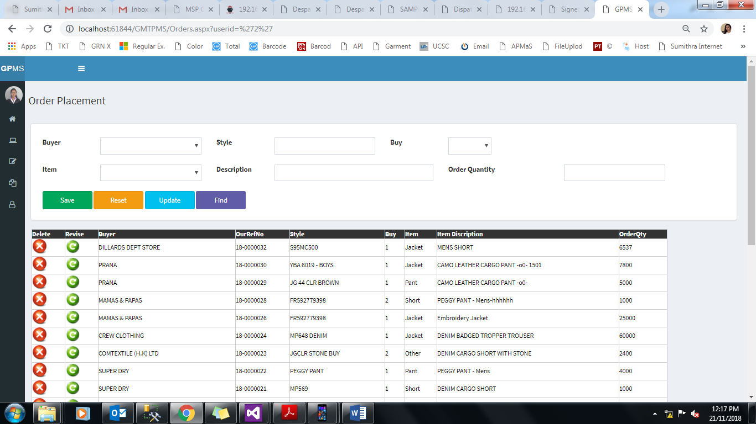

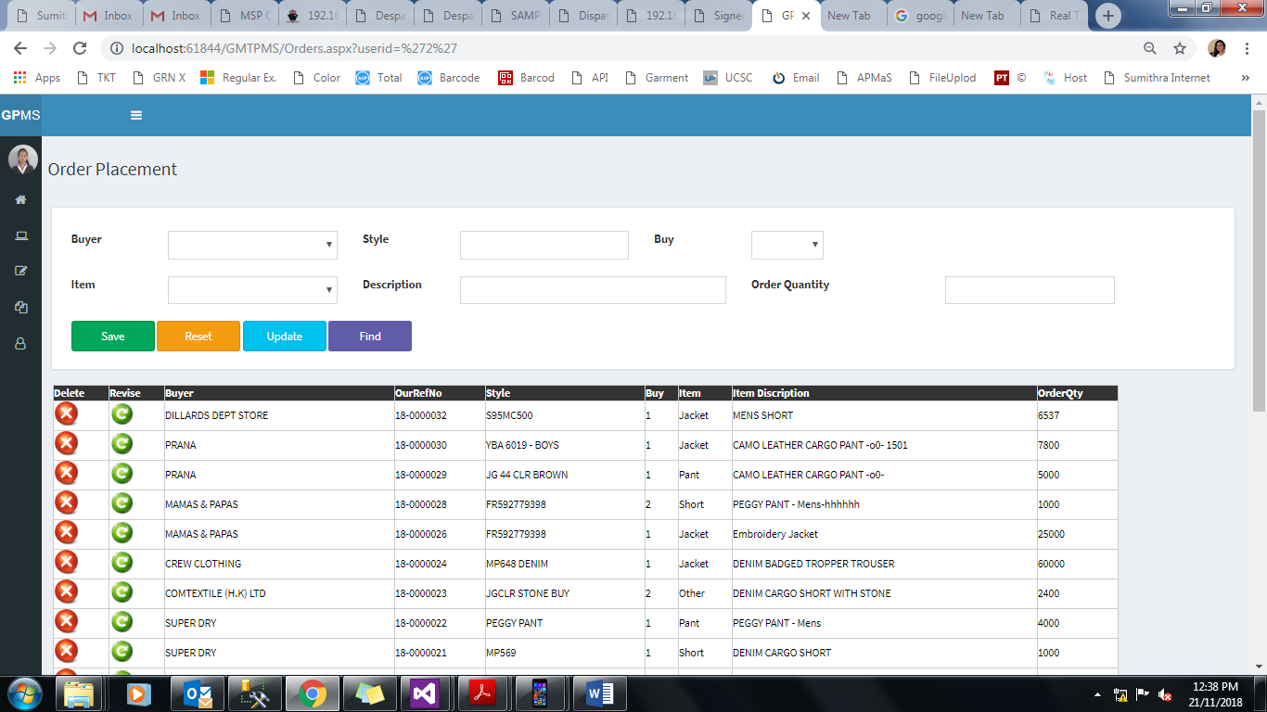

* User can add order details by filling Buyer, Style, Buy, Item, Description & order quantity



* User can clear all textboxes & drop-down values
* User can update buyer’s order information details , except the style number & buy no. After clicking the revise button on the order details table, selected details load to the relevant textboxes & dropdowns. Then user can update details after changing any data except the style number & buy no.

C:\Users\madhushika\Desktop\GMTPMS\images\readd.jpg



* User can filter data by buyer’s name & style no



* User can delete order details using this button

# Buyer Po Details

Once the user click on the Buyer PO Details link in main navigation panel, it will redirect to below given page. And users can add details about the buyer’s purchase order details using this page.

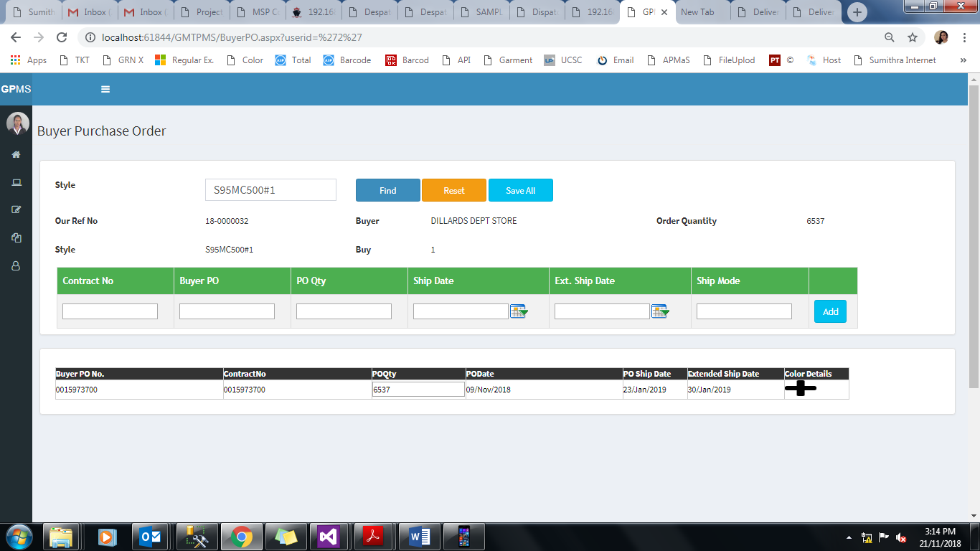

**5**

**4**

**3**

**2**

**1**

**1**

After selecting the style no, user can find style details such as Buyer, Order Qty and previously entered buyer purchase order details using this Find button

**2**

User can clear all the selected records using this Reset button

**3**

User can save and update all entered PO quantities using this Save All button

**4**

User can add new buyer purchase order details using this Add button

User can redirect to color details entering page using this C:\Users\madhushika\Desktop\GMTPMS\images\plusss.png plus button. When clicking on this plus button system showing color details panel like below.

**5**

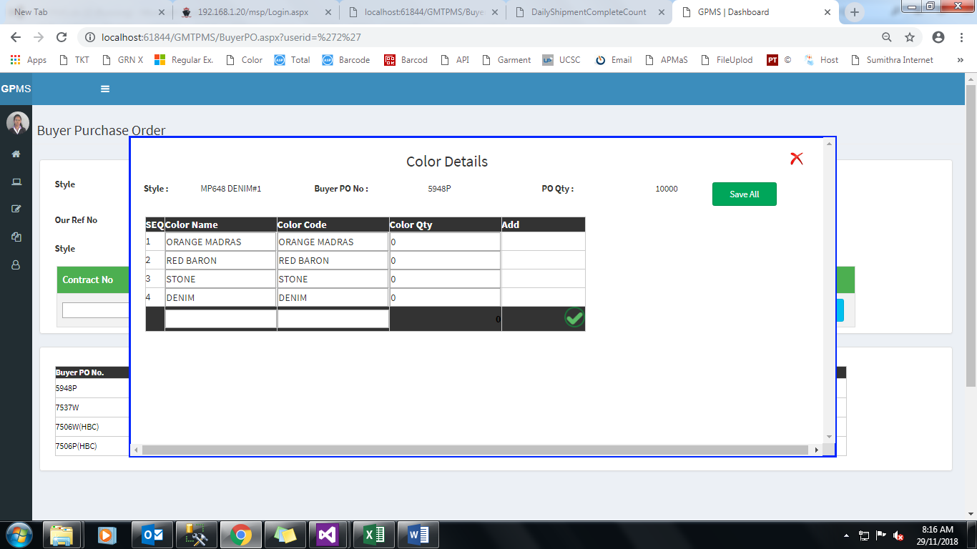

**7**

**6**

**6**

User can add color name & color code details using this add button

**7**

User can edit color detail with the color quantity using this save all button.

# Color Details

Once the user click on the Color Details link in main navigation panel, it will redirect to below given page. And users can add details about the buyer’s required color details using this page.

While explaining the buyer po process we explained this color details process also.

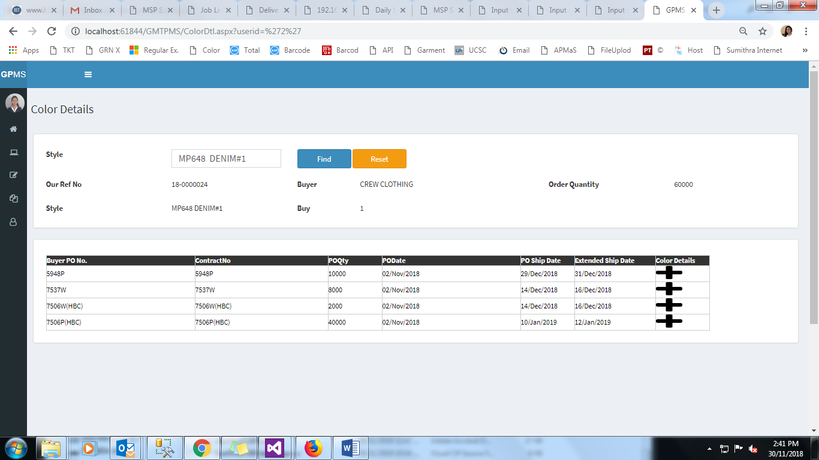

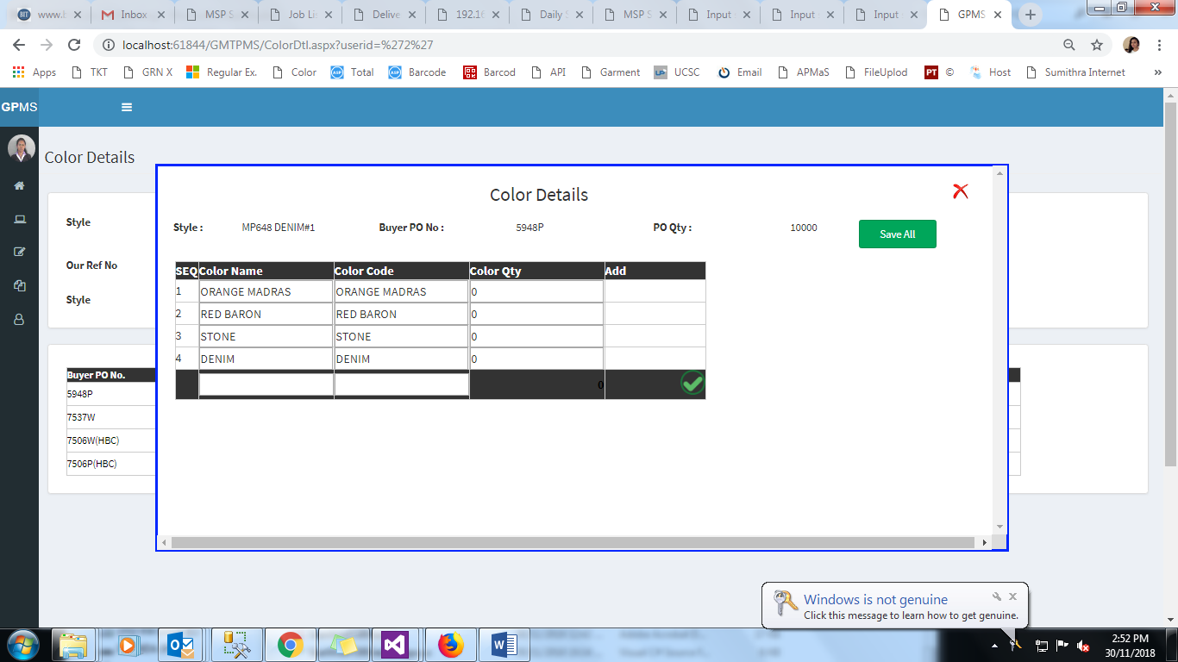

# Size Details

Once the user click on the Size Details link in main navigation panel, it will redirect to below given page. And users can add details about the buyer’s required color details using this page.

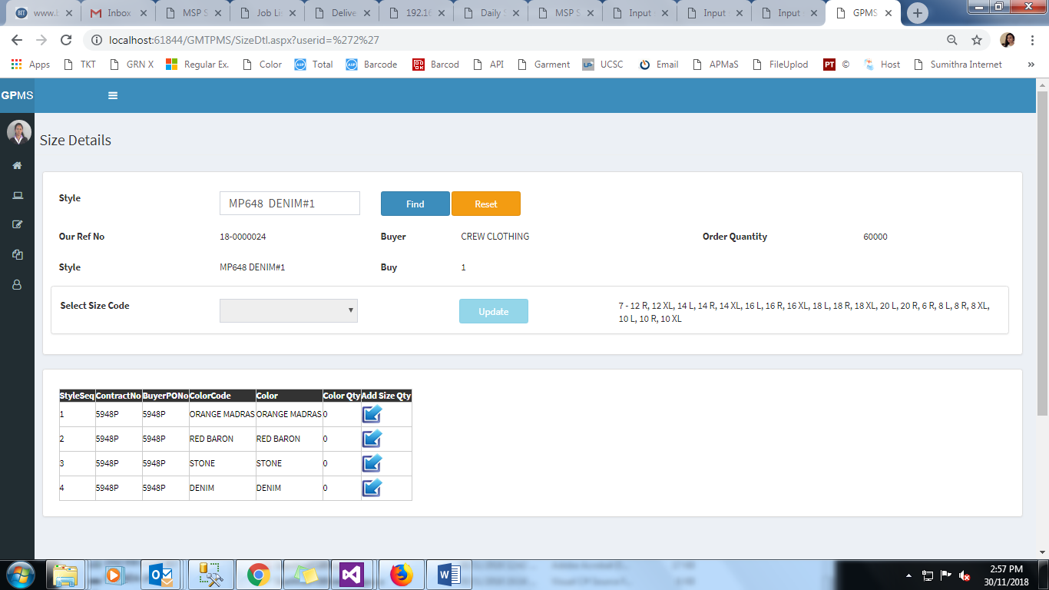

Previously entered color details showing like this